Social format

This format is oriented around one main [forum](https://docs.moodle.org/31/en/Forum_module" \o "Forum module),the social forum, which appears listed on the main page. It is useful for situations that are more free form. They may not even be courses. The [Moodle Lounge](http://moodle.org/course/view.php?id=55) is an example of a social format course.

[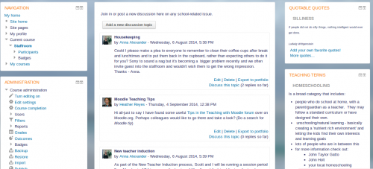](https://docs.moodle.org/31/en/File:SocialFormatN.png)

Social format example - click to enlarge

When selecting the social format, it is possible to specify how many discussions you wish to display on the course page:

[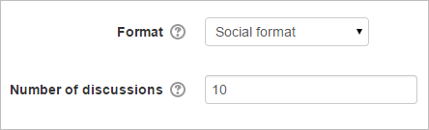](https://docs.moodle.org/31/en/File:socialformatdiscussions.png)

The social forum can be edited by clicking the 'Update this forum' button on the social forum page. The forum introduction is displayed at the top of the course page. Activities and resources can be added on the side by using the [Social activities block](https://docs.moodle.org/31/en/Social_activities_block).